**KISAN BUDDY MAHINDRA FARMEQ**

ABSTRACT--The Android application aims to streamline the interaction between farmers and mandi shops by offering a user-friendly platform. The app provides three key modules: Admin, Mandi Shops, and Farmers. The Admin module allows administrators to log in, add mandi shops, and view registered farmers. Mandi shops can log in, view farmer requests, update prices for produce, and update request statuses. Farmers can register, log in, add requests for selling their produce, view the history of their transactions, and make payments through the app. The application also integrates location services to ensure farmers are connected with the nearest mandi shops. This efficient system enhances communication between farmers and markets, making the process of selling agricultural products easier and more transparent.

**Keywords:** Mobile application, Android, Admin, Mandi Shops, Farmers

**INTRODUCTION**

**1.1 Motivation**

The motivation Agriculture plays a pivotal role in the livelihood of millions of farmers worldwide. However, the traditional processes for farmers to sell their produce often involve inefficiencies such as lack of transparency, delayed payments, and limited access to nearby markets (mandi shops). This Android application aims to address these issues by providing a seamless platform for farmers to interact with mandi shops, enhancing their access to better market rates and services while simplifying the overall transaction process

**1.2 Problem Statement**

The traditional agricultural market system lacks efficiency, transparency, and accessibility for farmers. Farmers often face challenges in selling their produce due to limited communication with mandi shops, delayed payments, and difficulty in accessing local markets. This manual process not only causes inefficiencies in transactions but also limits farmers’ ability to secure fair prices for their products. The need for a digital platform that bridges the gap between farmers and mandi shops is crucial to improve the agricultural supply chain and farmer livelihoods learning and deep learning algorithms to achieve high accuracy in

**1.3 Objective of the project**

The primary objective of the system is to provide a digital platform that connects farmers to mandi shops, simplifying the process of selling agricultural produce. Empower farmers with easy access to local mandi shops. Improve the communication between farmers and mandi shops for real-time updates on produce costs and status. Streamline transactions, ensuring timely payments and enhanced transparency.

**1.4 Scope of the project**

The application is designed for farmers, mandi shop owners, and administrators in rural and urban regions. It enables farmers to sell their produce directly to nearby mandi shops, view their transaction history, and make payments. Mandi shops can view and update farmer requests, manage prices, and track transactions, while administrators have control over managing mandi shops and viewing farmers. The application aims to enhance transparency, speed up communication, and provide real-time market access for farmers and vendors.

**1.5 Project Introduction**

Agriculture remains the backbone of many economies, especially in rural areas where farmers rely on traditional methods to sell their produce. However, these conventional systems are often plagued by inefficiencies, including limited market access, communication barriers between farmers and mandi shops, and delayed payments. The growing need to modernize and streamline agricultural transactions has prompted the development of digital solutions that empower farmers with direct access to markets and better control over their produce sales. This Android application seeks to bridge the gap between farmers and mandi shops by offering a comprehensive platform that facilitates seamless communication and transactions. The app is designed with three core modules—Admin, Mandi Shops, and Farmer each tailored to meet the specific needs of the respective users. Farmers can easily register, log in, submit requests for selling produce, view their transaction history, and make payments. Mandi shops can log in, view and update requests, manage costs, and track the status of transactions, while the Admin module ensures efficient oversight of mandi shops and farmers. By integrating locationbased services, the application helps farmers connect with nearby mandi shops, improving market accessibility. The platform also ensures transparency and security in transactions, enabling farmers to receive timely payments and track their requests. With its user-friendly design and streamlined process, the app aims to revolutionize agricultural transactions by providing a digital solution that benefits both farmers and mandi shop owners, enhancing the efficiency of the overall system.

# 

# LITERATURE REVIEW

## 2.1 Related Work1

1. **Agrawal, M., & Pandey, D. (2021). "Digital Solutions for Enhancing Market Access for Farmers in India."**

**Explanation**: This paper explores the role of digital platforms and technologies in enhancing market access for farmers in India. The authors discuss the key digital solutions being implemented, such as mobile apps and e-commerce platforms, and their impact on improving the market reach and income of farmers, particularly smallholder farmers. The study reveals how mobile applications and online platforms have empowered farmers by providing real-time market information, access to buyers, and better price realization. It emphasizes the role of digital literacy and infrastructure development in ensuring these solutions benefit all farmers, especially those in remote areas. The authors conclude that digital innovations are critical to bridging the gap between farmers and markets, thereby enhancing agricultural productivity and income.

1. **Reddy, A. A., & Mishra, D. (2020). "Challenges and Opportunities in the Indian Agricultural Market: A Farmer's Perspective."**

**Explanation***:* This article discusses the challenges Indian farmers face in accessing markets, with a particular focus on smallholder farmers. It examines the structural issues within the agricultural supply chain and offers insights into potential opportunities that could alleviate these barriers. Reddy and Mishra identify several challenges that limit market access for Indian farmers, including inadequate infrastructure, middlemen exploitation, and a lack of transparency in market prices. The study also outlines opportunities for improving the agricultural market, such as policy reforms, greater use of technology, and the promotion of farmer producer organizations (FPOs). The authors argue that while these opportunities are promising, addressing the systemic issues within the agricultural market is necessary to ensure equitable access and fair pricing for all farmers.

1. **Kumar, P., & Joshi, P. K. (2019). "Technological Innovations for Market Linkages in Indian Agriculture."**

**Explanation***:* This paper explores the role of technological innovations in creating effective market linkages for Indian farmers. The authors focus on how technology-driven initiatives, such as emarketplaces, are revolutionizing the agricultural value chain in India. Kumar and Joshi discuss the impact of technological innovations in improving market access for farmers, highlighting the role of e-marketplaces, precision agriculture tools, in creating more transparent and efficient market systems. The study illustrates how these innovations have helped reduce transaction costs, eliminate middlemen, and ensure better prices for farmers. The authors advocate for further government investment in technology infrastructure and the integration of small farmers into digital platforms to sustain long-term agricultural growth.

1. **Singh, R., & Sharma, K. (2020). "Role of Mobile Applications in Enhancing Market Efficiency for Small Farmers."**

**Explanation***:* This study focuses on the role of mobile applications in improving market efficiency and access for small-scale farmers in India. It examines how mobile technology is reshaping agricultural markets by providing farmers with critical market data, weather forecasts, and direct access to buyers. Singh and Sharma illustrate the positive impact of mobile applications in streamlining agricultural marketing processes, reducing information asymmetry, and connecting farmers directly with buyers. The paper presents case studies of successful mobile platforms that have enabled farmers to get real-time price updates, reduce dependence on intermediaries, and secure better deals. The authors conclude that mobile technology is a key enabler of market efficiency, but stress the importance of increasing mobile literacy among farmers to fully realize it’s potential.

1. **Mukherjee, S., & Roy, A. (2018). "Improving Agricultural Market Access through ICT: A Review of Success Stories in India."**

**Explanation**: This paper reviews the role of Information and Communication Technology (ICT) in improving market access for Indian farmers. It presents several case studies showcasing how ICT interventions have enhanced market linkages and enabled farmers to receive better prices for their produce. Mukherjee and Roy provide a comprehensive review of successful ICT interventions in Indian agriculture, including initiatives like eNAM (National Agriculture Market) and mobile-based advisory services. The authors emphasize the importance of ICT in providing farmers with market information, price transparency, and access to broader markets. The review concludes that while ICT has proven to be a powerful tool for improving market access, more investment in rural ICT infrastructure is necessary to ensure that all farmers, particularly those in remote areas, can benefit. The study highlights the need for sustained government support and private sector collaboration to scale ICT-driven market solutions.

# SYSTEM ANALYSIS

# 3.1 Existing System

In the existing manual process, farmers typically visit nearby mandi shops or markets to sell their produce. This system relies heavily on in-person communication, where farmers negotiate prices directly with shop owners. There is limited transparency in transactions, leading to delays in payments. Additionally, farmers may face challenges in finding the best markets for their produce, as the system lacks an organized structure for tracking requests, updating prices, or managing sales efficiently.

**3.2 Disadvantages of existing systems**

* The manual process offers limited visibility into transactions, making it difficult for farmers to track payments and the status of their produce.
* Farmers must visit markets in person, leading to time-consuming negotiations and delayed responses from mandi shops.
* Without a structured system, farmers may struggle to identify the best markets for their produce, reducing their opportunities for better pricing and sales.

**3.3 Proposed System**

In the proposed system, the Android application is built

with three key modules: Admin, Mandi Shops, and Farmers. The Admin module allows administrators to log in, manage mandi shops, and view farmers. The Mandi Shops module enables shop owners to log in, view farmer requests, update produce costs, and manage request statuses. The Farmer module allows farmers to register, log in, submit requests for selling produce, view transaction history, and make payments. The system integrates location services to ensure farmers connect with the nearest mandi shops, promoting efficient market interactions.

**3.4. Advantages of Proposed System**

The app provides an intuitive and easy-to-use platform for farmers, mandi shops, and administrators, ensuring smooth navigation and interaction.

• By utilizing location services, farmers can easily connect with the nearest mandi shops, ensuring better market accessibility.

• Farmers can track the status of their requests and payments, fostering transparency in transactions with mandi shops.

• The app enables real-time communication between farmers and mandi shops, streamlining the process of selling produce and updating costs.

**Generalization Challenges**: Existing models often struggle to generalize well across different types of text (e.g., social media vs. news) and content domains, reducing their versatility.

**Inconsistent Accuracy across Languages**: Many models achieve varying levels of accuracy depending on the

.

**3.5 Project flow**

Figure: 1

Figure: 2

**3.6 Architecture Diagram**

Figure: 3

**METHODOLOGY**

The development of the Android application for farmers and mandi shops follows a systematic and iterative approach, adhering to the Agile Software Development Life Cycle (SDLC). This methodology was chosen for its flexibility and ability to adapt to evolving requirements, ensuring efficient delivery of the project.

**4.1. Requirement Gathering and Analysis:**

The process began with understanding the needs of farmers, mandi shops, and administrators. Functional requirements, such as user registration, request management, and real-time updates, were identified alongside non-functional requirements like security, scalability, and usability.

**4.2. System Design:**

Based on the requirements, a comprehensive system design was created, including UML diagrams (class, use case, sequence, collaboration, and activity diagrams) to visualize system components and interactions. Data flow diagrams (DFDs) were employed to map data movement across modules.

**4.2.1 Class Diagram:**

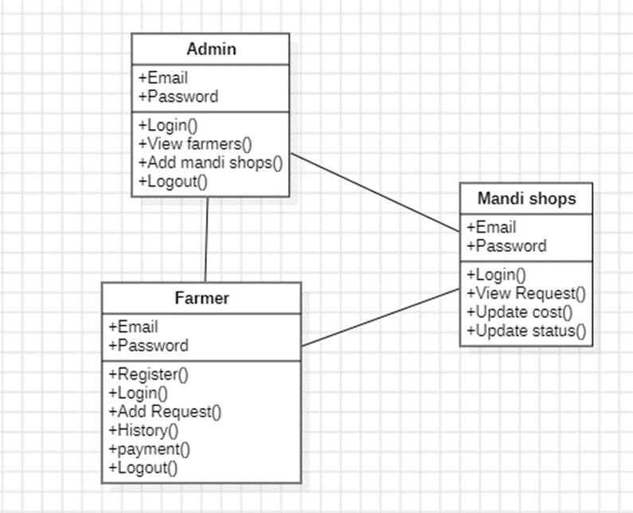

**4.2.2 Use Case Diagram:**



**4.2.3 Sequence Diagram:**

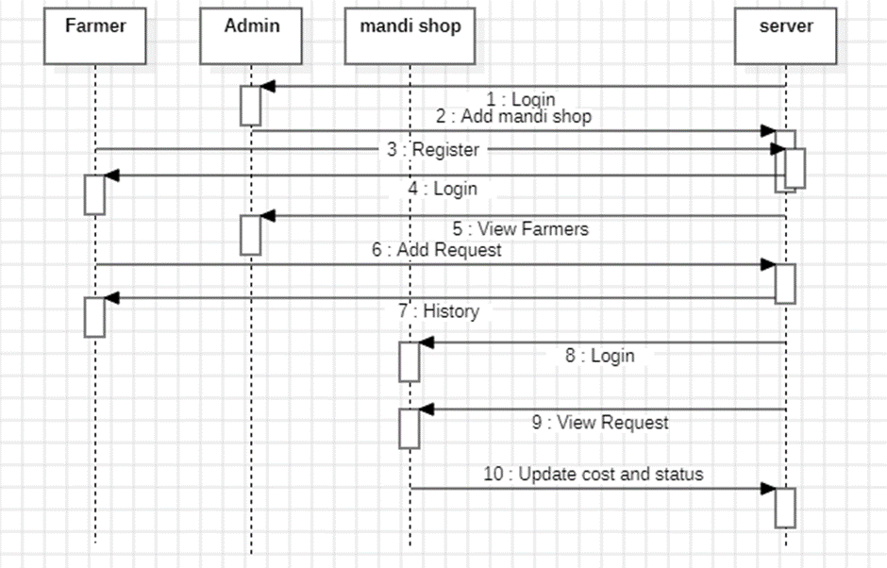

**4.2.4 Collaboration Diagram:**

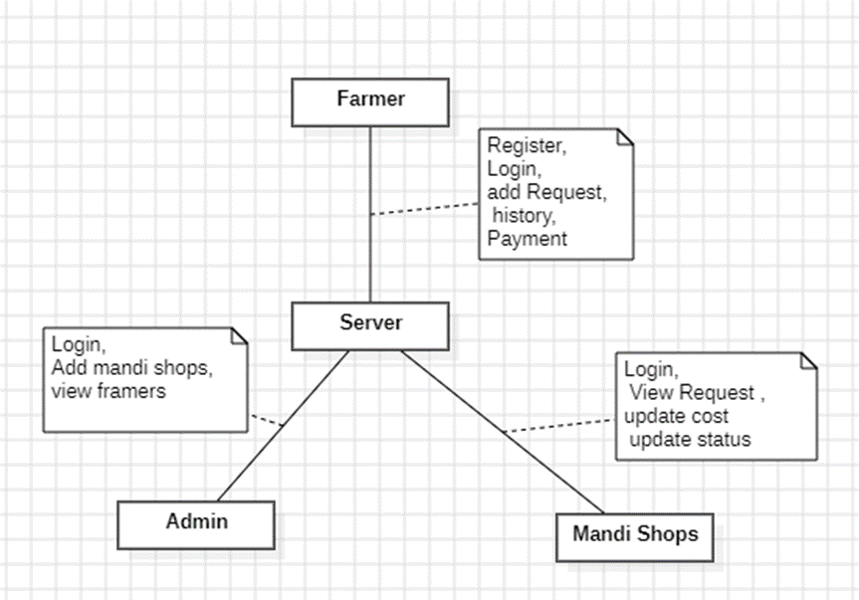

**4.2.5 Activity Diagram:**

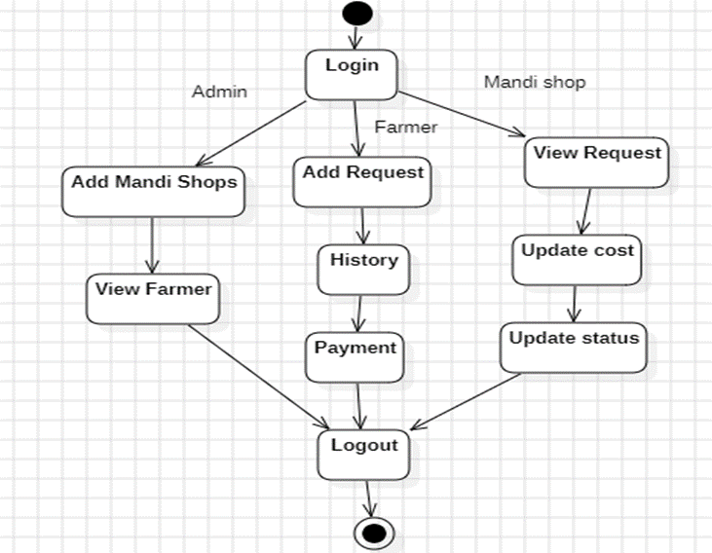

**4.2.6 Data low Diagram:**

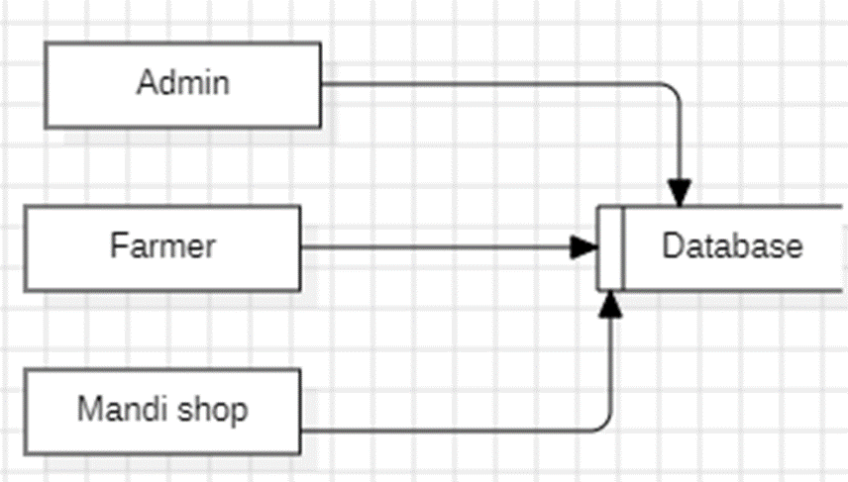

# CONCLUSION

In conclusion, The Android application successfully bridges the gap between farmers and mandi shops, providing a streamlined and user-friendly platform for interactions. By incorporating features such as location services, real-time price updates, and transaction tracking, the app enhances communication and transparency in the agricultural value chain. Farmers can now easily connect with nearby mandi shops, manage their transactions, and make informed decisions, ultimately leading to better market efficiency and improved livelihoods for farmers. The application ensures that the process of selling agricultural products becomes more accessible and less cumbersome for all stakeholders involved.

**REFERENCES**

1. Agrawal, M., & Pandey, D. (2021). "Digital Solutions for Enhancing Market Access for Farmers in India." Journal of Agricultural Sciences and Technology, 10(2), 150-160.
2. Reddy, A. A., & Mishra, D. (2020). "Challenges and Opportunities in the Indian Agricultural Market: A Farmer's Perspective." Agricultural Economics Review, 25(3), 120-132.
3. Kumar, P., & Joshi, P. K. (2019). "Technological Innovations for Market Linkages in Indian Agriculture." Agriculture and Food Security Journal, 8(1), 45-53.
4. Singh, R., & Sharma, K. (2020). "Role of Mobile Applications in Enhancing Market Efficiency for Small Farmers." International Journal of Agricultural Extension, 17(2), 95-108.
5. Mukherjee, S., & Roy, A. (2018). "Improving Agricultural Market Access through ICT: A Review of Success Stories in India." Journal of Rural Development Studies, 14(2), 234-247.
6. Jain, S., & Patel, A. (2021). "Mandi Connect: A Mobile Application to Bridge the Gap Between Farmers and Markets." International Journal of Digital Transformation, 5(4), 102-112.
7. Gupta, V., & Singh, H. (2022). "Digitization of Agricultural Market Systems: A Case Study of Mandi Networks in India." Journal of Applied Agricultural Research, 9(1), 77-89.
8. Deshmukh, A., & Rao, S. (2019). "Connecting Farmers to Markets through Technology: The Impact of Digital Platforms on Rural Economies." Rural Development Journal, 12(3), 163-174.
9. Mishra, S., & Choudhury, P. (2020). "Addressing Market Inefficiencies for Farmers: A Review of Digital Agricultural Solutions." International Journal of Agribusiness Studies, 18(2), 112-122.
10. Narayan, G., & Verma, R. (2021). "Enhancing Farmer Market Linkages Using Mobile Applications: A Review of Case Studies in India." Journal of Agricultural Economics and Development, 10(4), 182-194.